1. Once you log in to your IBM Cloud account, you'll be redirected to your IBM Cloud Dashboard.  You can access all of your IBM Cloud services from your Dashboard at any time by clicking **IBM Cloud** at the top left of the Dashboard page. In your IBM Cloud Dashboard, click **Search resources and offerings...** in the field at the top of the page.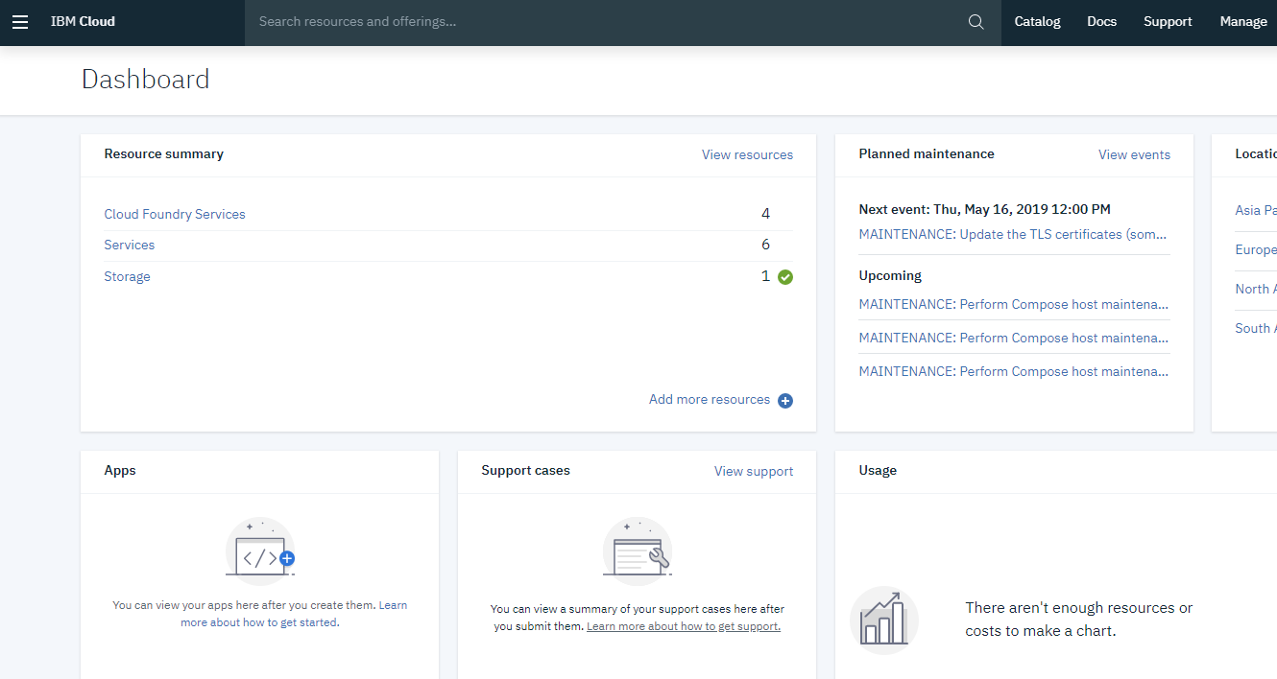
2. **Enter** the letters "**Db2**" in the search field to find all of the Db2 related services you can provision through the IBM Cloud Catalog. Click **Db2 Warehouse** that is listed under the **Catalog Results** category to navigate to the IBM Cloud Catalog page for Db2 Warehouse on Cloud.  
   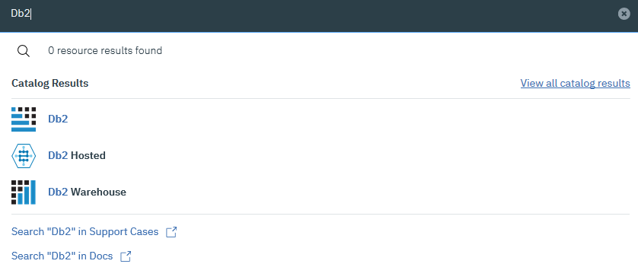
3. You can deploy Db2 Warehouse on Cloud in many datacenters around the world. , select the **Dallas** location in the IBM Cloud Catalog page.

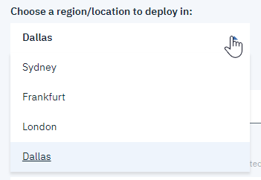

1. Scroll down the page to see the different Db2 Warehouse on Cloud plans that you can deploy you’ll be deploying and using a Flex One system. Click **Flex One**.                      
     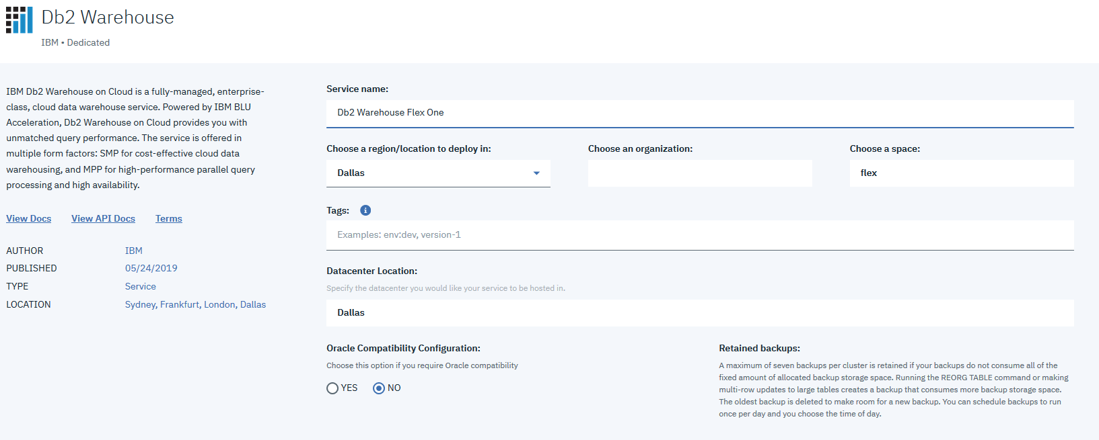
2. For this tutorial, enter **Db2 Warehouse Flex One**as the Service name.

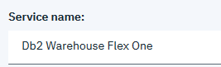

1. To create your Db2 Warehouse on Cloud instance, click **Create**.
2. Your Db2 Warehouse on Cloud instance takes a few minutes to provision. When provisioning completes, you’ll be taken to your Resource list page:

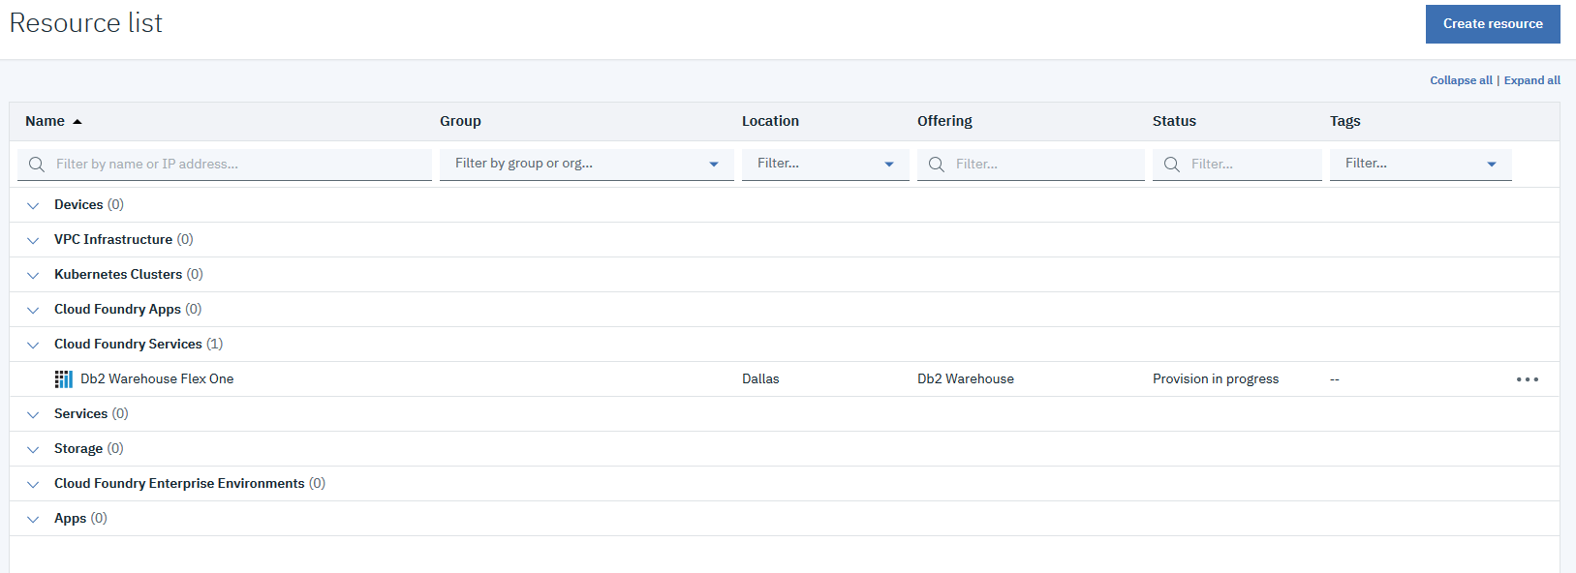

1. When your Db2 Warehouse on Cloud instance is ready, you can open the service launch page for your instance.  From the service launch page, you can view “Getting started” information, open the web console for your instance, and even scale the storage capacity and compute cores for your instance.  In the next task, you’ll learn how to retrieve the credentials for your Db2 Warehouse on Cloud instance that you use to log in to your instance’s web console.

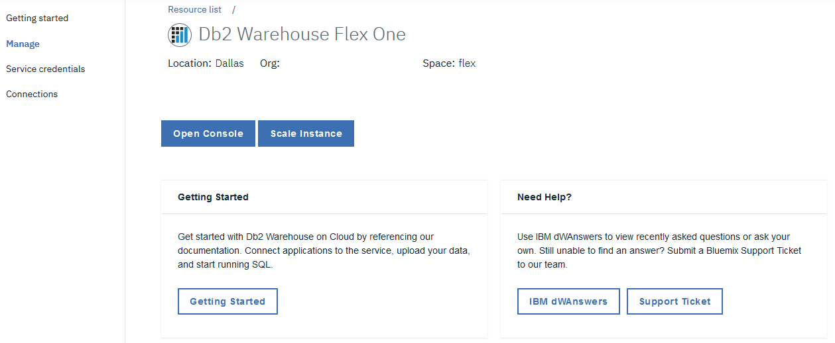

Retrieving Db2 Warehouse on Cloud service credentials

In this task, you’ll learn how to retrieve the credentials for your Db2 Warehouse on Cloud instance.  You can use these credentials to log in to the web console for your Db2 Warehouse on Cloud instance, and to connect your Db2 Warehouse on Cloud instance to business intelligence tools like Cognos Analytics or data integration tools like DataStage

1. Select the **Service credentials** menu item on the left side of the service launch page for your Db2 Warehouse on Cloud instance.

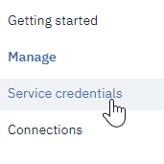

1. To create a new set of service credentials for your Db2 Warehouse on Cloud instance, click **New credential**.
2. Enter a name for your Db2 Warehouse on Cloud service credentials. If you have just created the service in the first, optional step of this tutorial, enter **Db2WarehouseFlexOne** (no spaces are allowed). If you are using another service, use the name of that service. Click **Add**.

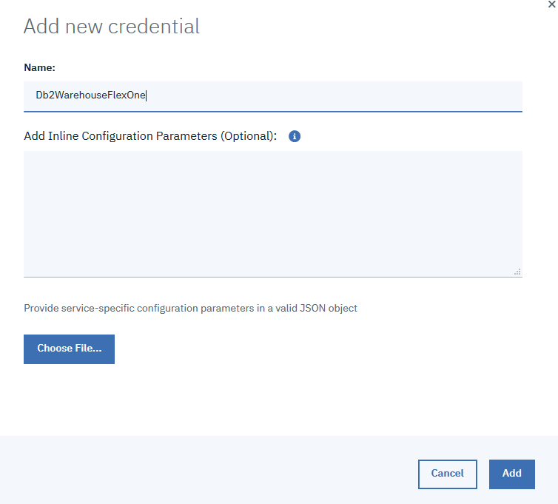

1. Select the down arrow next to the **View credentials** action to view the created credentials. You’ll see the user name and password for the service. In the next task, we’ll use your newly created credentials to access the web console for your Db2 Warehouse on Cloud instance.

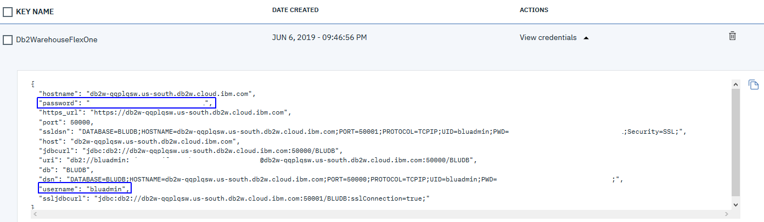

Touring the Db2 Warehouse on Cloud web console

In this task, you’ll take a quick tour of the Db2 Warehouse on Cloud web console.

1. Select the **Manage** menu item on the left side of the service launch page for your Db2 Warehouse on Cloud instance.  
   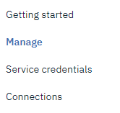
2. To open the web console, click **Open Console**:

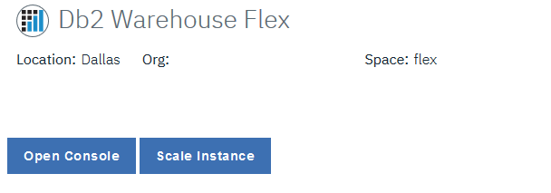

1. The login screen of the web console opens in a new browser tab.  You can log in by using the credentials that you created in the previous task:

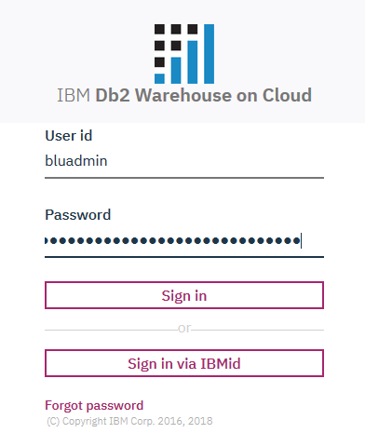

1. Upon log in, you’ll be taken to the Overview page of the web console for your Db2 Warehouse on Cloud instance.  The Overview page contains useful information about your instance, including database responsiveness, throughput, and resource contention.

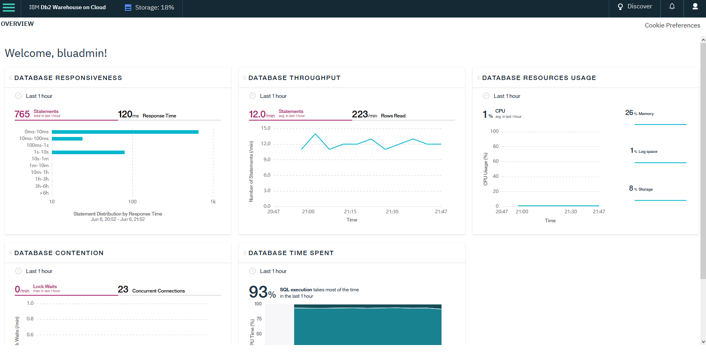

1. The Db2 Warehouse on Cloud web console is rich with functionality. You can do  many things, from loading data into your Db2 Warehouse on Cloud instance to managing users.  Click the hamburger menu in the upper**-**left corner to see all of your options:  
   image-20190515161618-3
2. Select **Explore** to view the schemas and tables available in your Db2 Warehouse on Cloud instance.  The main schema for your instance is named BLUADMIN.  If you click BLUADMIN, you’ll notice there are no tables. We'll discuss how to load data into your Db2 Warehouse on Cloud instance in the second part of this tutorial.  
   